**Problems for lab report**

For all programs, take screenshots of both code and output and paste the screenshots into a .pdf report file.

**10]** ► Similar to Problem 1, but find how long it takes to triple the initial deposit.

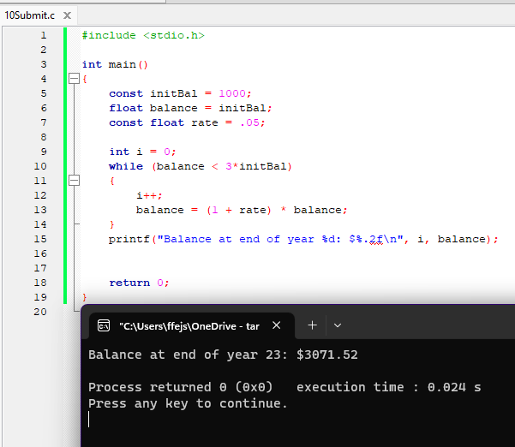

**11]** ►Write a program that prints all the multiples of 3 from 1 to 36 (on the same line).

Now change it so it prints all the multiples of 3 in reverse order.

**12]** ► Same as above (the multiples of 3 in reverse order), but with a **do…while** loop.

**13] ►** Write a program that prints all the numbers from 1 to 200 that are at the same time multiples of 4 and multiples of 6. Please note that this does not mean just the multiples of 24, for example 12 is M4 and M6, but not M24.

Hint: Use the logical and operator **&&**.

**14] ►** Similar to problems 5 + 6: Write a program that creates an array of 1000 random integers, finds their minimum, and prints it.

